2 - Asynchronous Programming

Learning Outcomes
On completion of this lab you will have learned how to:
- Implement an interactive user interface in JS using event handling
- Process JS objects and arrays (from JSON) preferably using a functional style
- Read and process remote JSON documents using promises
- Implement a simple networked-UI using DOM API first principles

Organisation
Please complete the exercises individually.

Grading
This worksheet is worth up to 10% of your overall module grade.

You may work on this worksheet during lab 3 and lab 4 with instructor assistance. You may also be requested to demonstrate your submission to the lab instructor in order to receive credit.

Submission
The deadline for submission is Sunday Oct 19, 2019 @23:59 through Brightspace.
.

- The work and submission workflow is as follows:
- Create a sub-folder for each problem below. problem-1, problem-2, problem-3 etc.
- Put your solution for each problem in their respective folders.
- When you are finished developing your worksheet solution, compress and zip all problems into one zip file. Name this <student-id>-lab-1.zip
- <student-id> is something like C12345678
- Upload to Brightspace Lab 2 / Lab 2 - Upload

Resources
You are free to research whatever you need to solve the problems in this lab. Some recommended resources include:
- https://developer.mozilla.org/en-US/docs/Web/API/Document_Object_Model
- https://developer.mozilla.org/en-US/docs/Web/JavaScript
- https://www.codecademy.com/learn/javascript

Problem Sets
Provide Javascript ES6 code for the following problems using JS Bin or your own development environment as you prefer.

When submitting, clearly identify what code solutions are associated with which problems.

Note: Keep your JS Bin URLs private to you. Do not share these with class colleagues.

1 | Phone Directory:  Phone Directory is a web application that allows a user to manage contacts.  Once a contact is saved, it appears in a table.  The list can be sorted by name.  The list can be filtered by phone number.  Functionality:  It has three fields Name, Mobile and Email. All 3 are required fields. Clicking on the Add Contact button should add the contact to the table. Before adding a contact, the following validations should occur:  Name - Should contain only Alphabets and Space. Should be less than or equal to 20 characters in length.  Mobile - Should contain only Numbers.Should be equal to 10 characters in length.  Email - Should have a proper validation and should be less than 40 characters in length.  Show an error div with id 'error' if there is any error in input format or if there is any empty field.  Valid contacts should get added sequentially in the table.  After adding a valid contact, all fields should be reset to empty.  Clicking on the Name heading in the table should sort it by ascending order of the contact name. Further clicks should alternately sort descending then ascending.  The search should begin as soon as an input is typed by the user in the search field. It should filter rows based on the mobile number given in the search field.  If there is no matching row for the search term, then the div with id 'noResult' should be made visible. It should be hidden otherwise. Odd numbered data rows should have #f2f2f2 as the background color. Exclude <th>.  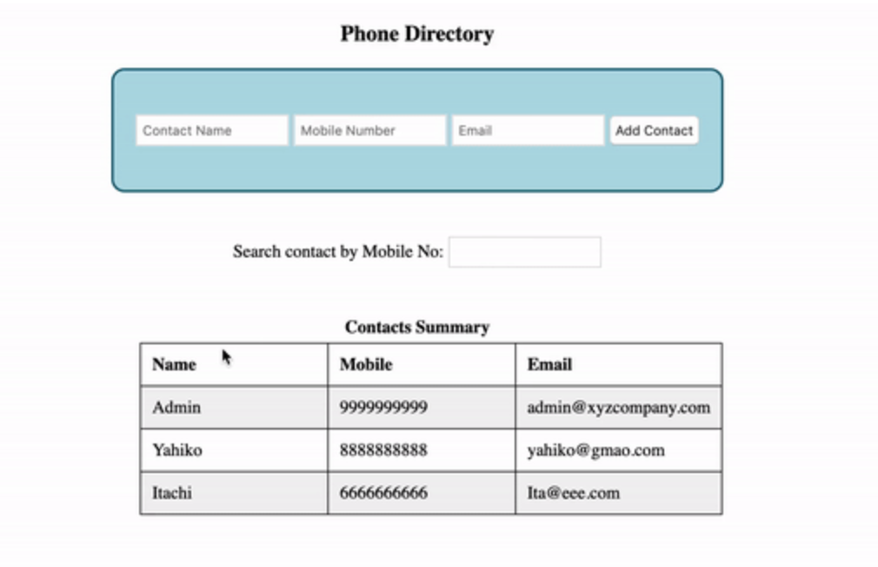 | 35  Marks
2 | For this problem refer to the lecture on array operations and consult the documentation at:  https://developer.mozilla.org/en-US/docs/Web/JavaScript/Reference/Global_Objects/Array  https://developer.mozilla.org/en-US/docs/Web/API/Fetch_API  The API you will work with is here:  http://jsonplaceholder.typicode.com  Using this API and the functional programming style of array operations, provide code to solve for the problems below. You MUST USE this FP style with functions such as map, reduce, filter, flatmap and so on. If you find yourself using loops, you’re doing it wrong. Carefully think through which data transformations you need to apply in which order in your pipeline.  For each answer, use console.log() to display the data (i.e. you do not have to build DOM objects):  - List all of the post titles having more than six words  - Show a word frequency map for all of the body contents of the posts | 15 Marks
3 | You will build a web application for querying user information from the Github API that looks like the following:  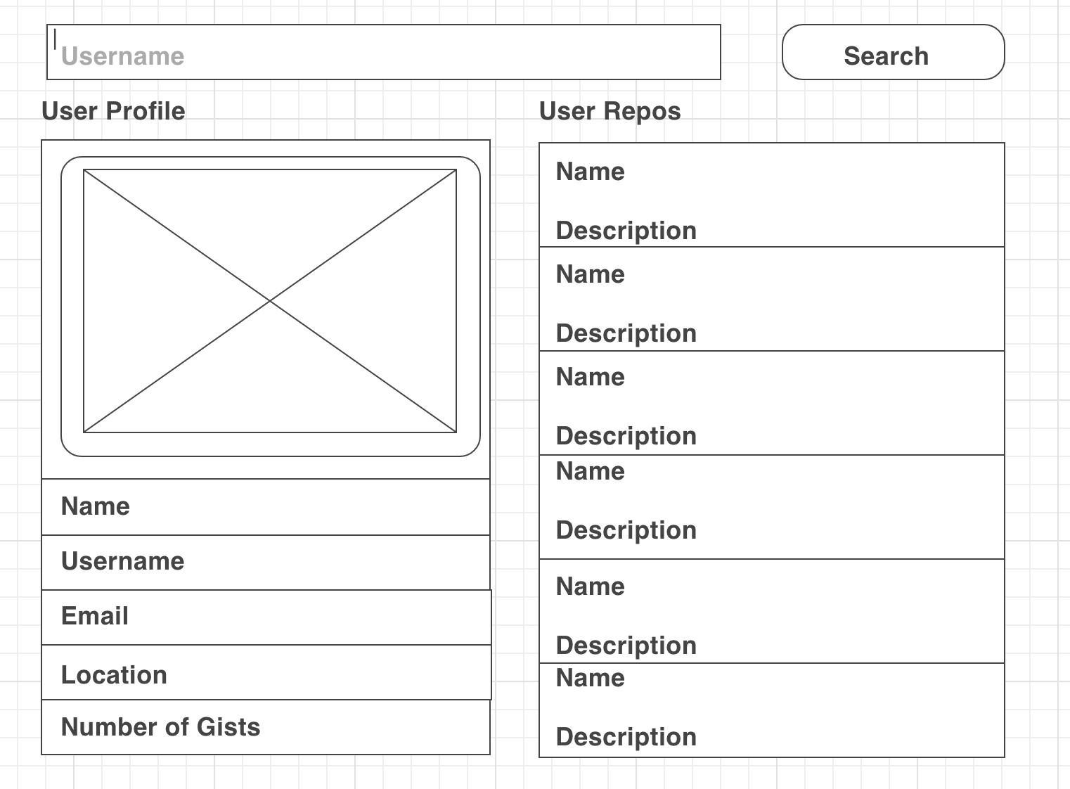  Notes:  - Use only native APIs, Javascript, HTML and CSS (no external libraries permitted)  - You may use whatever style of async programming primitives you like such as callbacks, promises or streams.  - The API endpoint for retrieving user information is https://api.github.com/users.  - The user of your application can input a username and search in Github for that user’s information  - The information should be displayed as shown, including the avatar picture at the top left  - The repo information can be obtained by following the “repos_url”. You should implement a scrollable list to display these if the number exceeds 5  - Marks will be awarded for code quality such as formatting and how DRY your code is | 50 marks
Please work on this yourself and do not be tempted to plagiarise a solution, even in part, from a colleague or from the Internet.

